Anthony Ventura

Linux Administration

Getting System Setup

Ubuntu Server

Welcome to the introduction of how to install Ubuntu in virtual Box.

Step 1: I opened my virtual box to start creating my machine. I selected “New” to create my machine.

Step 2: I selected my location folder for my virtual machine. After, I selected my default settings for the virtual disk. After that I selected the ISO file for the ubuntu machine. After I was done, I got to the screen to choose the language of the server. I selected English for the server and hit Enter.

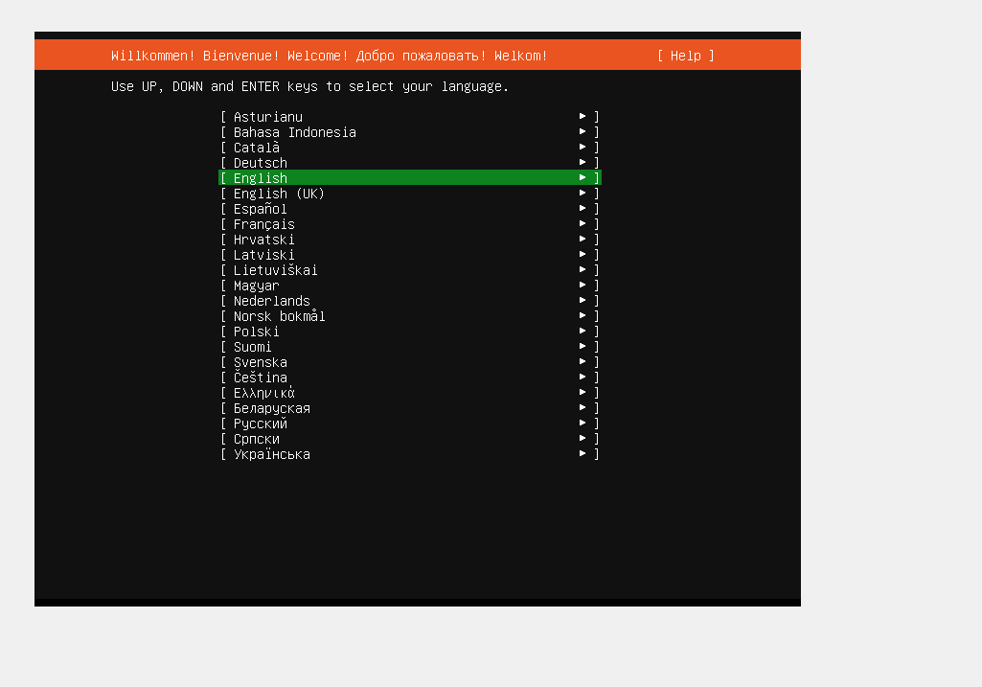

Step 3: After I read the network connections and I selected “Done”

Step 4: After that screen I started creating my username and the password of the machine. I selected to install the network settings; you have to wait couple minutes to finish installing the other installations

Step 5: After the installation is done is going to show you the login screen of the machine. I entered my username and my password, and I was able to login.

